DO FB Channel FAULT

# Design inputs

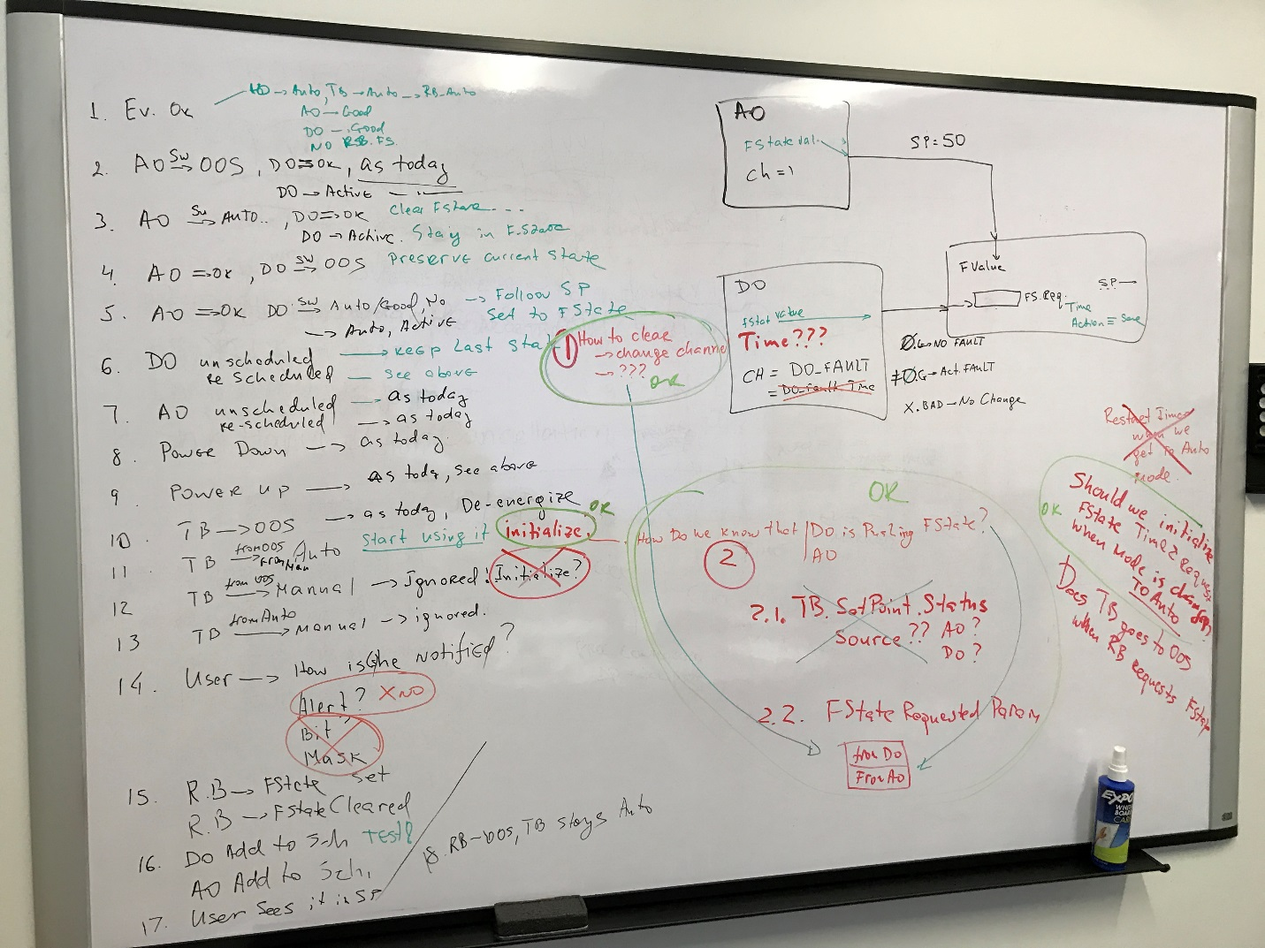

# Derived design

(Source: TFS28831)

1.      XD_FSTATE controls fallback to a setpoint as configured (full closed, full open, stay in position, fixed setpoint) on the following conditions:

a.      Controlling output block, according to TB.SETPOINT_SOURCE has FINAL_VALUE_x.STATUS BAD or substatus “Initiate failed state”.

                                                    i.     In this case, the time is counted and when it reaches FSTATE_TIME_1, the fallback setpoint is used

                                                   ii.     When TB changes actual mode to AUTO, the time counter is reset

b.      A DO FB has CHANNEL=CH_DO_FAULT and its output is GOOD and TRUE

                                                    i.     In this case, the fallback setpoint is used immediately

                                                   ii.     The DO FB request is latched until changed to GOOD and FALSE

                                                  iii.      When the DO FB output is not GOOD, the last GOOD request is latched, in particular, when the DO FB is stopped (such as OOS).

1.      This is so even if the FB is no longer scheduled

2.      To cancel a stale DO FB request, the user can:

a.      change the CHANNEL of the DO FB to something else, or

b.      write 0 to FSTATE_STATUS.REQUEST (see below)

2.      At most one DO FB may have CHANNEL=CH_DO_FAULT

3.      When the fallback setpoint is used, it is indicated in SETPOINT.STATUS substatus “Initiate failed state”.

4.      FSTATE_STATUS parameter (new) indicates

a.      Flag of active fallback due to DO FB or user request

                                                    i.     Writing a 0 will cancel DO FB request, whether stale or not. If not stale, next execution of the DO FB will refresh it.

**ii.     Writing a 1 will have the same effect as DO FB request, whether or not there is a DO FB that could make such a request**

b.      Flag of active fallback due to FINAL_VALUE_x, read-only

c.      Time until activation of fallback due to FINAL_VALUE_x, read-only

5.      On reset/power-up, TB doesn’t preserve any old DO FB requests and starts with fresh XD_FSTATE internal state, just as it does w.r.t. FINAL_VALUE_x.

# 